Table of Contents

1. Purpose

1.1. Intended Audience

1.2. Intended Use

1.3. Scope

1.4. Definitions and Acronyms

2. Overall System Description

2.1. Use Case Diagrams

2.2. System Architecture

2.3. Functional Requirements

2.3.1. Start up and main menu

2.3.2. Scanner Starts

2.3.3. Payment choice

2.3.4. Remote Access

2.3.5. Authentication Services

2.4. Non-Functional Requirements

2.4.1. Power Management

3. Software Architecture

3.1. Static Software Architecture

* 1. **Purpose**
  2. **Target Audience**

This SRS document describes the System Requirements and Software Design for a Self-Checkout Kiosk system for Supermarkets with a online checkout system for an mobile Application. Target Audience are System and Software Engineers working on the development of this project.

* 1. **Intended Use**

The SRS defines System Architecture and Requirements as well as the Software Architecture and Design. This document contains the definition of the System Requirements which shall be used as the input for System Test cases and Software Unit Test Cases.

* 1. **Definitions and Acronyms**

|  |  |
| --- | --- |
| **Acronym** | **Description** |
| BUZ | Buzzer |
| NFC | Near Field Communication |
| SW | Software |
| HW | Hardware |
| PICAM | Raspberry PI Camera |
| LCD | LCD display |
| KEY | Numeric Keypad |

**2 Overall Systems Description**

* 1. **Use case diagrams**

1. **Online and Physical Purchasing**

* 1. **System Architecture**

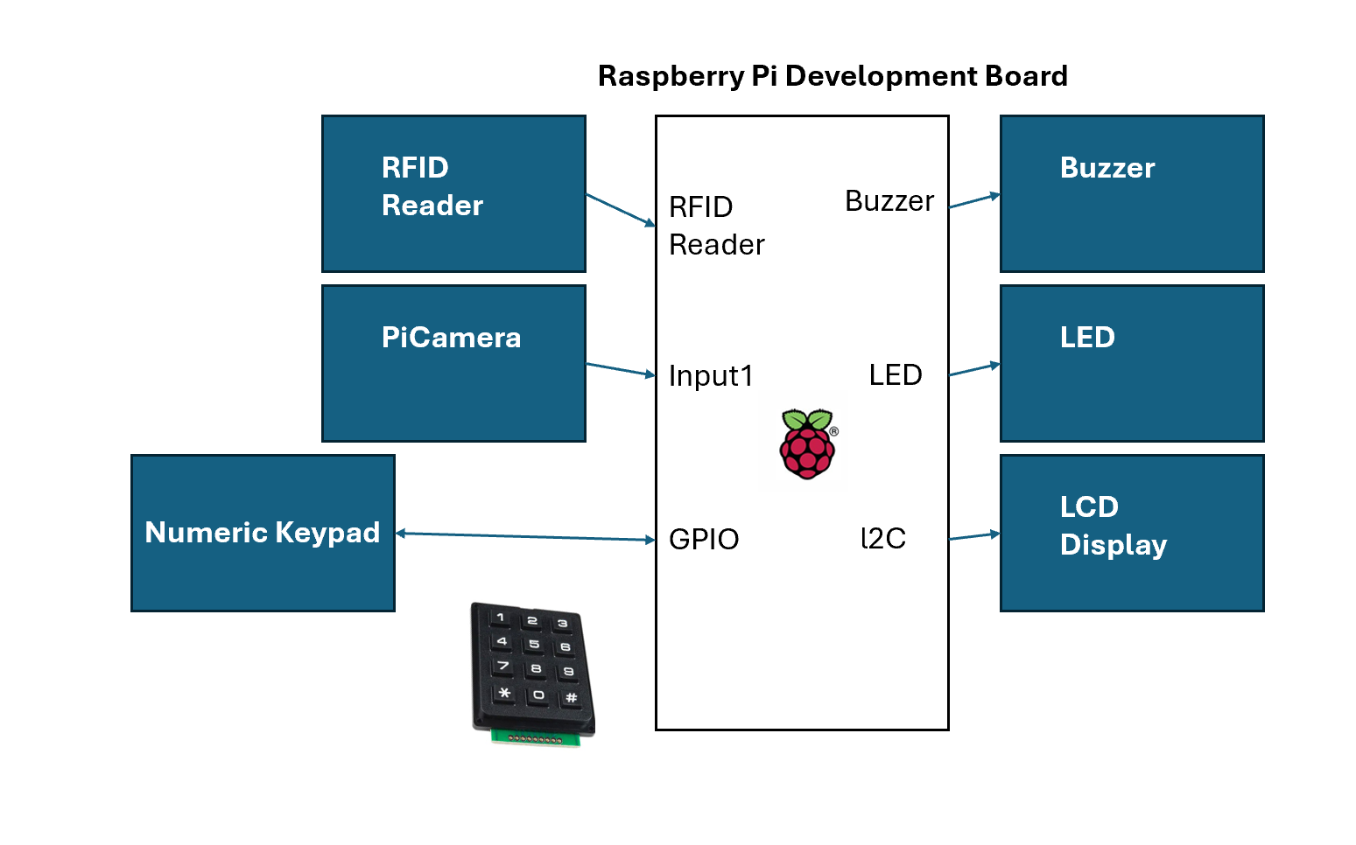

* 1. **Functional Requirements**
     1. **Start up and Main Menu**

|  |  |
| --- | --- |
| **REQ-ID** | **Requirements** |
| **REQ_01** | When Bar-code scanner is first powered ON, the main menu with the text below shall be displayed on the LCD screen:  Line 1 = “1. Scanner Start”  Line 2 = “2. Power Off” |
| **REQ_02** | In the main menu defined in REQ-01, if the option “1. Scanner Start” is selected on the keypad, then the following menu shall be displayed on the LCD screen  Line 1 = “Scan ready”  Line 2 = blank |
| **REQ_03** | In the main menu defined in REQ-01, if the option “2. Power off” is selected, the LCD should display the following text for 2 **seconds** and then turn off the LCD display and back light and enter the LOW Power Mode state.  Line 1 = “Powering Off” |

* + 1. **Scanner Start**

|  |  |
| --- | --- |
| **REQ-ID** | **Requirement** |
| **REQ-04** | From REQ-02, PICAM is implemented to scan and read barcode to find the 10 unique identifier numbers to be mapped to a product on the database. |
| **REQ-05** | From REQ-04, Upon Scanning and successful read of barcode to find the 10 numbers, Buzzer turns on for 1 second in default tone before turning off until another barcode is scanned and read. |
| **REQ-06** | From REQ-04, use the price of product found to calculate total cumulative pricing. LCD will display the Product name; Price of product; Total sum; Payment in the following format  Line 1 = “Name: Price”  Line 2 = “Total, Payment” |

* + 1. **Payment Choice**

|  |  |
| --- | --- |
| **REQ-ID** | **Requirement** |
| **REQ-07** | From REQ-06  LCD Display will show as follows:  Line 1 = “1 - PAYWAVE”  Line 2 = “2 - ATMPIN”  Numpad is used to select the payment type. To select PayWave Payment Type by RFID, press 1 on the Numpad Input.  To select ATMPIN Payment Type, press 2 on the Numpad input |

* + 1. **Remote access**

|  |  |
| --- | --- |
| **REQ-ID** | **Requirement** |
| **REQ-08** | **Choose item through website**  When adding items to cart, system will display total price and quantity of items  Pay for all the items (assume they have account and will automatically deduct money from there)  **After paying will Choosing of items through the website when finished, can choose from self-pick up or delivery**  When delivery is chosen will inform that there is cost of $4 delivery charge  If customer chose self-pick up, system will produce a QR code which will be sent after payment.  **Show QR code to verify the order and collect** |

* + 1. **Authentication Service**

|  |  |
| --- | --- |
| **REQ-ID** | **Requirement** |
| **REQ-09** | Choosing of items through the website when finished, can choose from self-pick up or delivery.  When delivery is chosen, the system will inform that there is a delivery charge of $4  No charge if customer chose self-pick up |

* 1. **Non-Functional Requirements**

**2.4.1 Auto Cancellation**

|  |  |
| --- | --- |
| **REQ-ID** | **Requirement** |
| **REQ-10** | If no inputs have been detected from REQ-2 onwards, for 1 minute, code will return to REQ-1 |

1. **Software Architecture**
   1. **Static Software Architecture**

The software architecture defines the various software components that are developed to realize the implementation of the system requirements.

Application Layer

Scanner.py

Payment.py

Power_start.py

Hardware Abstraction Layer (HAL)

NFC

hal_adc.py

hal_buzzer.py

hal_keypad.py

hal_lcd.py

hal_rfi_reader.py